COURSE: CLOUD AND NETWORK SECURITY _C1-2024

STUDENT NAME: LENNIE NTHIGA
STUDENT NO: cs-cns07-24170
SEPTEMBER 17,2024

WEEK 1 ASSIGNMENT 1
CLASS EXERCISE: EXAMINE TCP/IP AND OSI MODELS IN ACTION

INTRODUCTION
For this exercise we would be examining a request sent to server from a client the request might be a web page. Since data moves in small pieces also known as packets each packet has to have a unique identifier with protocols that they follow. This data’s protocols have to communicate when exchanging data using a unit called protocol data unit PDU when a communication and transfer is occurring between the client and the server.
Packet tracer has the tools and functionality which enables one to view the communication that are taking place within the specific layers of the OSI model and the TCP/IP

PART 1
The client would go ahead to a browser of the computer (web client) and search for www.osi.local website which the response to that request from the web server would be the statement below

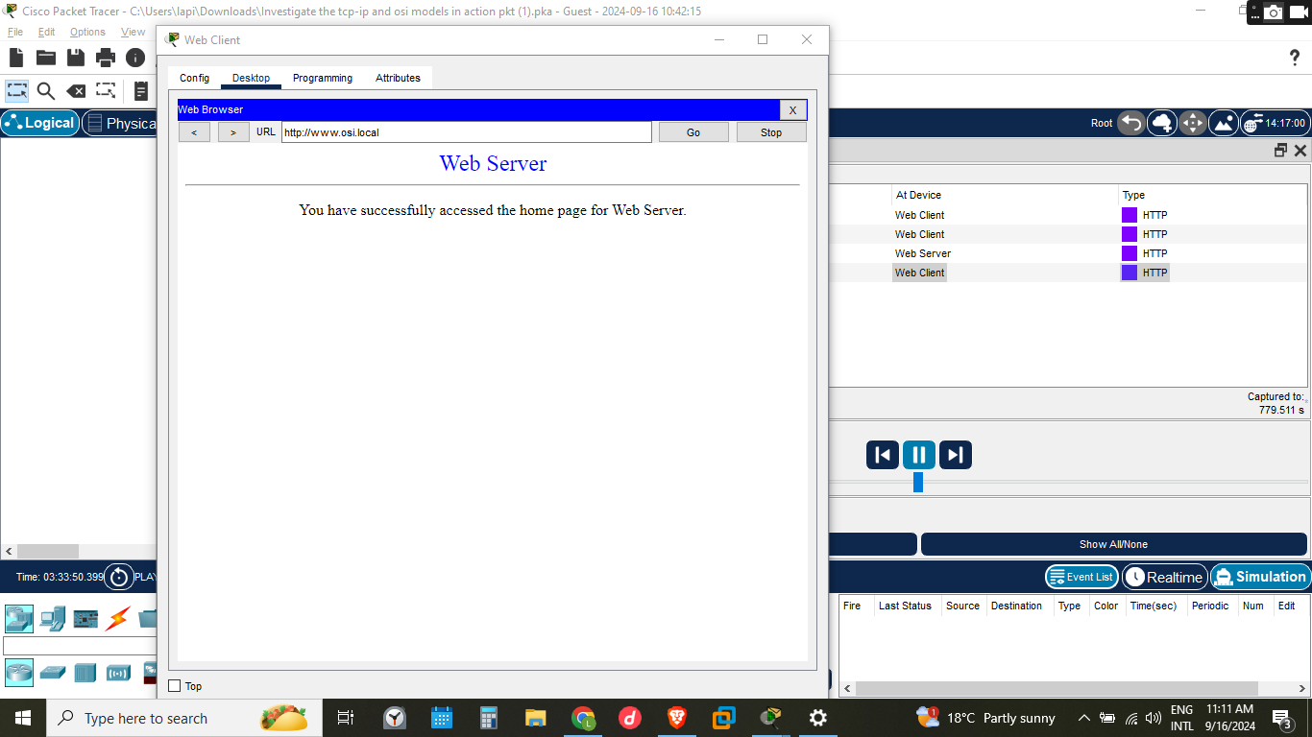

In analyzing the events that occurred from the sending of the website to receiving the message showed, one would have to set the specific protocol they want to monitor at the edit tab and choose e.g. http to get PDU information on the communication that occurred which came to be 4 events.
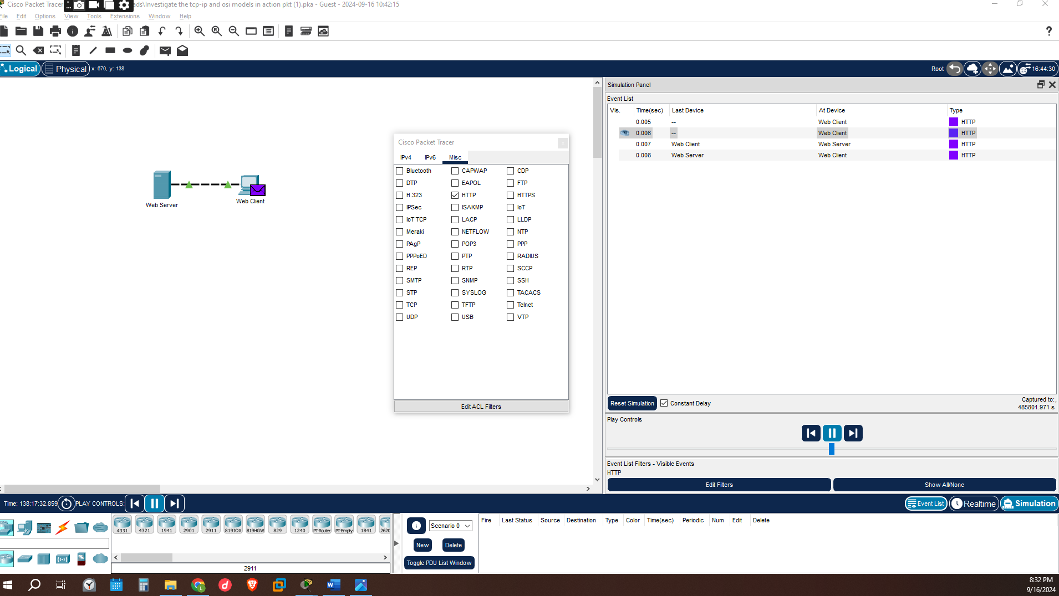

- Upon close study of the PDU information for each, event one would find two tabs OSI model and the outbound details while on another event there might be three which are OSI model, inbound model and outbound model. This occurs due to, when a client searches for a website, they send a request to the webserver thus the information would be indicated in the OSI model and the outbound details and when receiving a response, it would have the OSI model and the inbound details of the data while the server has to have the OSI model, inbound detail for the data that was requested and outbound details for where its sending

- The below shows the PDU information of the request made in http protocol

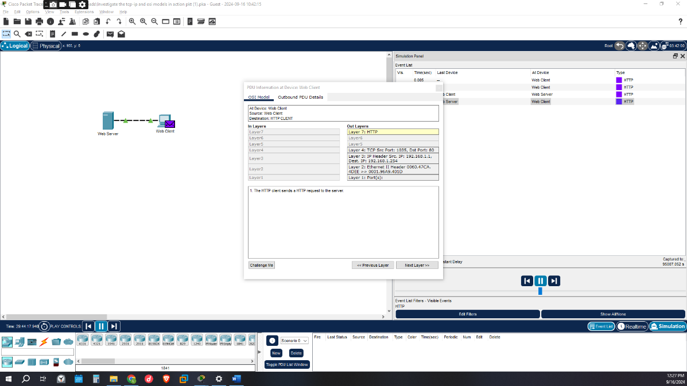

The outbound details would have information of the request which would include the source Ip 192.168.1.1 and destination Ip 192.168.1.124 and destination port 1035 and source port 80 ack and sync numbers for the TCP/IP hand shake, the destination Ip and source mac address are also displayed making this three being the common data in the TCP model and OSI model making while the TCP model has more PDU information of the data packet being sent
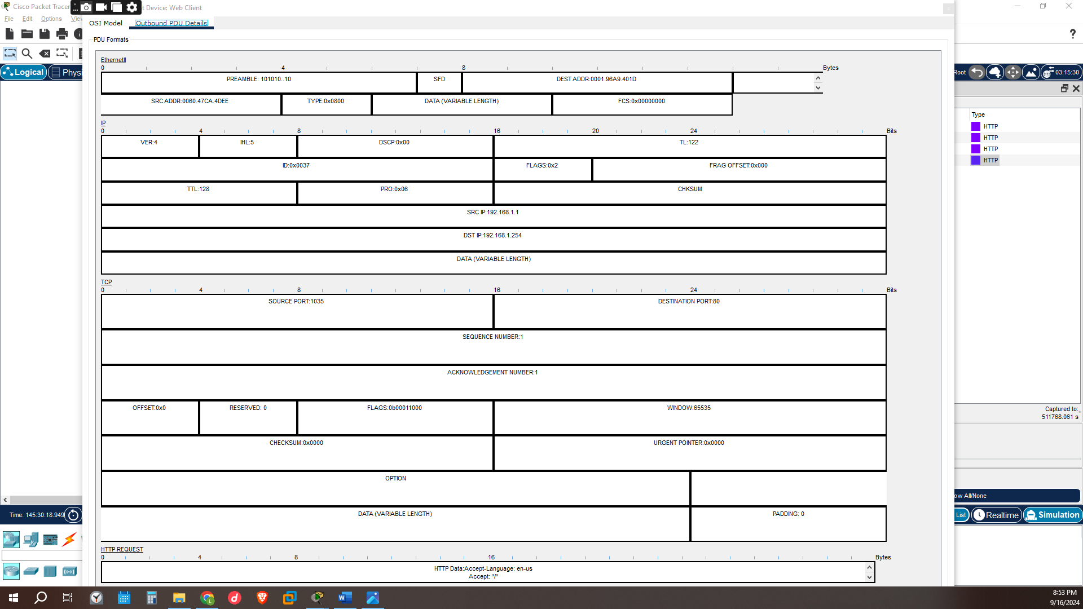

- Here displays the transfer of the request using the ethernet to the webserver
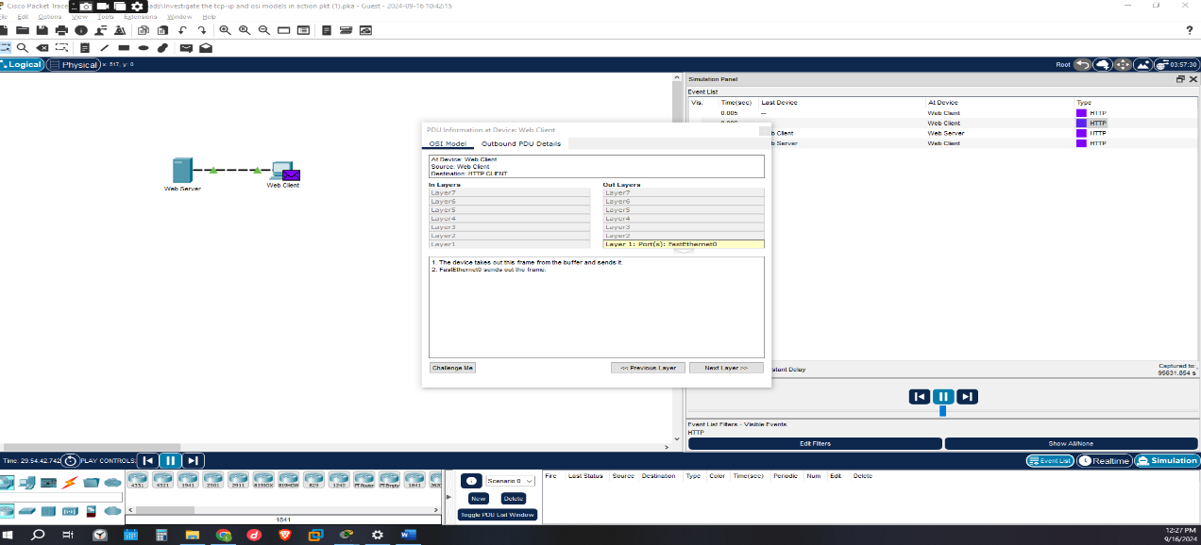

- The webserver would contain data in the inbound and outbound details including the OSI model and the necessary data used in the transfer as one would see the information in the in layer and out layer the osi model layer 4 would have the source Ip and the destination Ip but in a different format as of the layer 3 mac address of the destination and the source Ip

This is because in the in layer the Ip header has to show the source of the data then the destination it’s supposed to go to while the out layer would show where the destination Ip then the source Ip
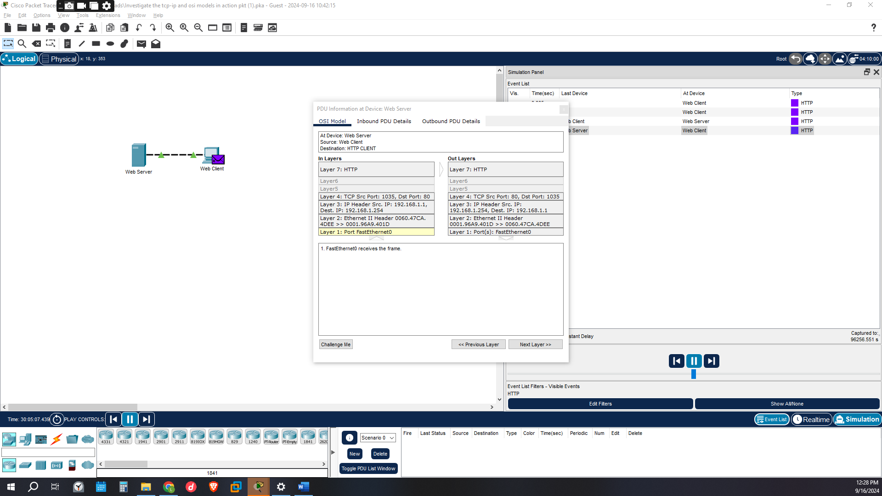

- This being the final event which is the response received from the server, the inbound PDU details has the source and destination port, the source and the destination Ip of the data, data including the length, the destination and the source mac address all of them used in the accomplishment of sending the right data packets to the right web client. 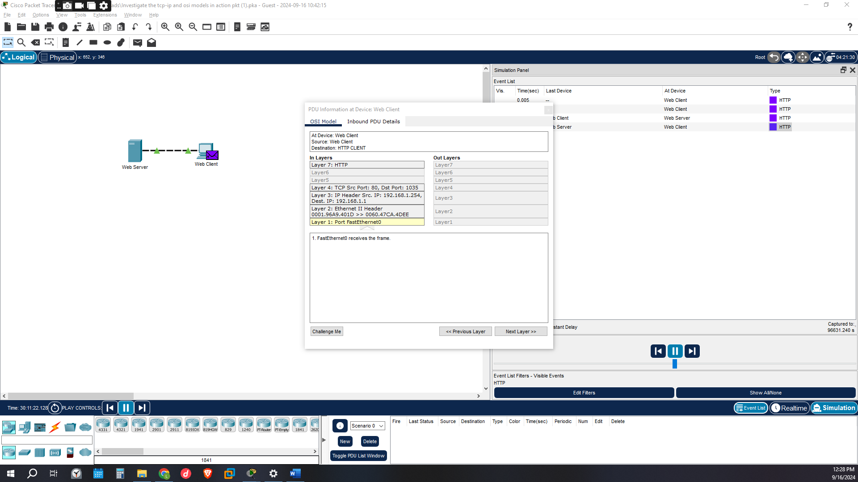

PART 2

During the communication of the web client and the web server there were many protocols that were to be involved, in which when a client inputs the www.osi.local address the server does not recognize that it recognizes the Ip that represents it since not everyone can have a memory of all those Ips the dns (domain name service) acts as the database for such Ips and addresses and converting them, the Arp (address resolution protocol) that requests for the mac address of the destination host. And many more protocols that could be involved according the nature of the requests done
Here we would have selected the show all protocols to show all protocols involved in the communication that were captured

For this instance, we capture dns, tcp, http and Arp protocols events in packet tracer
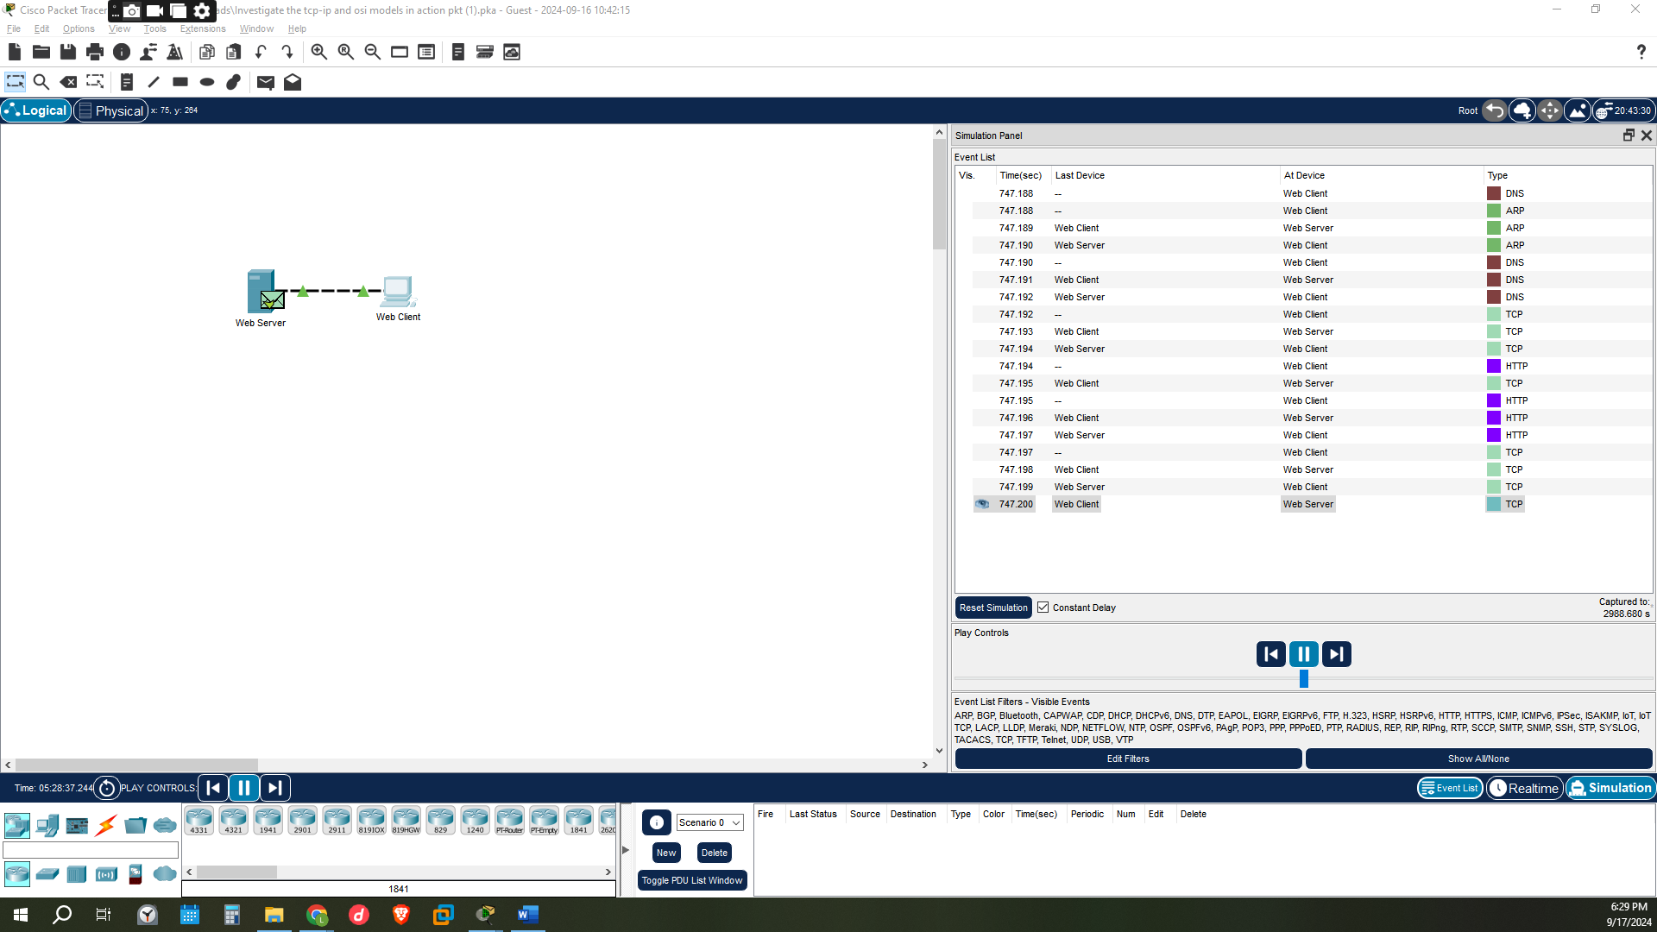

When the client sent a request that is the www.osi.local web address the dns query would be sent to the dns sever the PDU information would be encapsulated into udp segment. The source Ip is not specified but the destination Ip is in the same subnet thus the device sets the next hop to destination. The Arp process looks for the Ip address in the Arp table and doesn’t find it thus sending an Arp request to that Ip address buffering the udp encapsulated packet. The device encapsulates the Arp request into ethernet frame and sends it .The fast Ethernet 0 receives the frame and the destination mac address matches the receiving ports mac address/might be a broadcast address or multicast address, decapsulates the PDU from the ethernet frame the Arp processes the frame and matches the Ip address to the receiving ports Ip address and updates the information to the Arp table in the web server .The Arp process replies the request with the receiving ports mac address thus encapsulating the PDU information into an ethernet frame and sending it to the web client .The web client receives the frame the destination mac address matches decapsulates the PDU information processes the Arp information and updates the received information into the Arp table .The Arp process takes out the buffering packet(udp) encapsulates the PDU information into an Ethernet frame and sends it .The webserver would receive the frame matches the destination mac address decapsulates the pdu information from the Ethernet frame in layer 2 and in layer 3 the destination Ip address is checked and matches the devices Ip address and decapsulates the pdu information from the udp segment in layer 4 and encapsulates it again now the server has known the destinations Ip address is in the same subnet and sets the next hop to the destination .The Arp process looks the destinations is in Arp table finds it and the Arp process sets the frames destinations mac address to the one found in the table encapsulates that pdu information into ethernet frame and sends it. The client receives the frame matches the mac address decapsulates the pdu information from the ethernet frame. The device matches the destinations Ip address and decapsulates the packet from the udp segment. Now the http tries to make a connection with the sever 192.168.1.124 on port 80 here it uses the tcp handshake. The device sends the SYN segment which is a sequence number 0 and acknowledgment number 0. The destination Ip is looked up In the Arp table and found sets the frames destination mac address to the one found in the table encapsulates the pdu into Ethernet frame and sends it. The server receives the frame the destinations mac address is matched and decapsulates the pdu information and the Ip address of the destination is also matched. Receives the tcp syn segment from the port 80 and the device /server sets the connection state to SYN_RECEIVED. The device sends a TCPSYN+ACK segment with ack being1 sequence number 0. The server sets the Ip address as the next hop and the Arp checks the table to set the Frames destinations mac address to the one found encapsulates the frame to ethernet frame and sends it. The client’s device receives the frame checks the mac address and matches check the destinations Ip address matches and decapsulates the packet. The client receives the tcp segment TCPSYN+ACK segment and sets the connection to ESTABLISHED now the sequence number is 1 and ack number is 1.
This basically being the process a request is made from the web client to the web server with more tcp processes to make sure the process of communication and transferring the data is accomplished by the server.

PDU information for one of the dns event where the Ip address of the destination Ip address is in the same subnet but not found in the Arp table
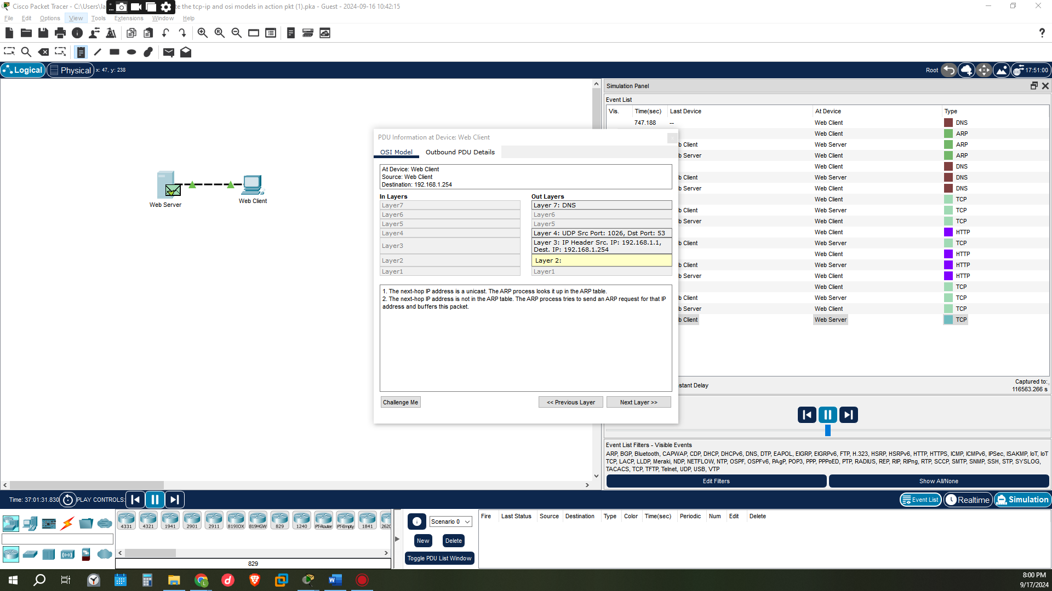

PDU information for one of the Arp events where the Arp request is encapsulated into an Ethernet frame 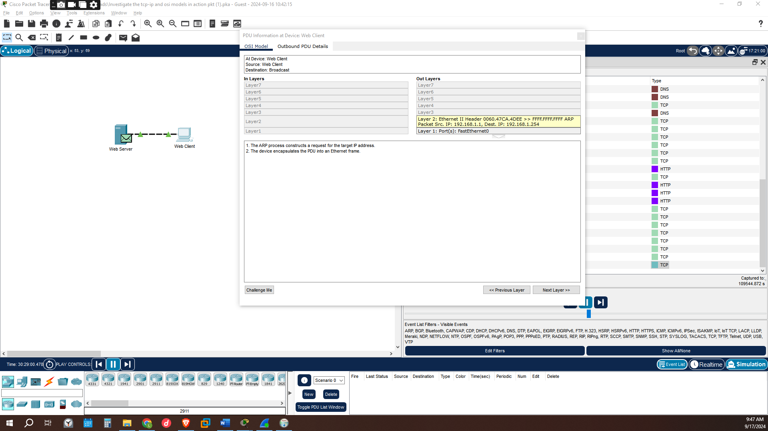

This is a tcp event where the http has tries to make a connection with the serve thus have to make a tcp handshake of setting the device connection to SYN_SENT state
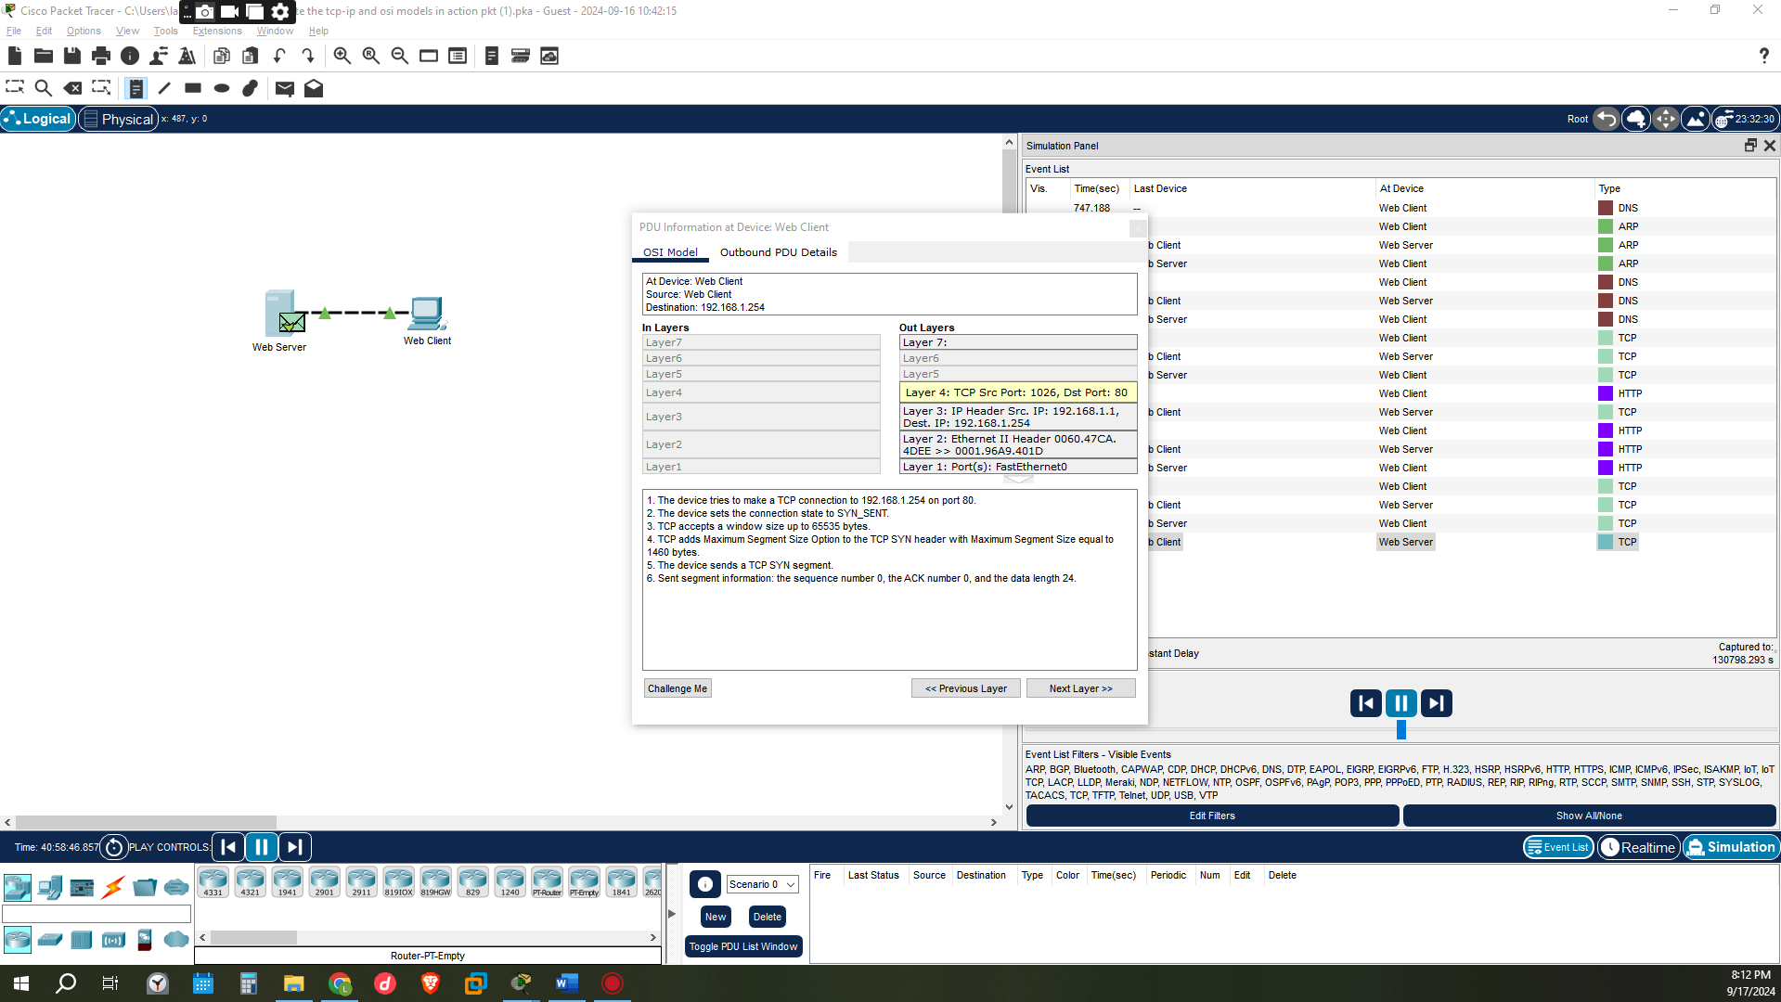

CONCLUSION
This activity has opened up the process under taken for a user to receive a desired web page from a server in details from when the domain name is searched in a browser ,to the lookup of the Arp table for the destination mac address to the capsulation process ,the tcp connection made from the web client to the web server and the final stage of the user receiving the requested web page from the server .The activity has out lined the numerous checking of the packets destination Ip and mac address in the web server and the web client to check if it’s the correct frame before the decapsulation of the received frames in which acts as a security feature for the connection.

